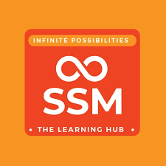 **SSM INSTITUTE OF ENGINEERING AND TECHNOLOGY**

**Dindigul – Palani Highway, Dindigul – 624 002.**

**BLOOD DONATION AWARD – 2022**

Indian Red Cross Society, Indian Medical Association and Meenakshi Mission Hospital-Regional Blood Transfussion Centre in a co-hosted ceremony, Meenakshi Mission Hospital on 1st November 2022. At the ceremony, to our college SSMIET, they have provided the recognition award for blood donation service.

